From: https://davidstockmanscontracorner.com/bernankes-black-ships-of-monetary-folly-and-the-scourge-of-central-banking-part-4/

Bernanke's Black Ships Of Monetary Folly and The Scourge Of Central Banking, Part 4
By David Stockman. Posted On Monday, April 15th, 2019
If you need a reason to be very afraid of the casino, an excellent one is that the world economy is now being run by economic crackpots. We are referring to officials such as New York Fed President, John Williams, US President, Donald Trump, and practically every foreign central banker you care to name---and most especially the king of money printing madness, Haruhiko Kuroda, head of the BOJ.
Kuroda showed up on CNBC this morning and with a straight face assured the world that in response to Japan's slowing economy (again) the BOJ "still has room for further easing". That could be accomplished by cutting both long-term and short-term rates and, if need be, by embarking upon a "larger asset purchase program".
You really do have to ask: Really?
Here's Japan benchmark 10-year government bond (JGB). Back on the eve of the global financial crisis in early 2008, the 10-year JGB at least had something which could be called a yield---even if only a paltry 1.5%. But that had already been reduced to 0.7% when Kuroda launched a new super-round of QE in March 2013, which money printing spree drove the yield below the zero bound by early 2016---where it has stayed pretty much ever since.
In short, the benchmark bond of the most indebted government in the world (Japan's public debt is about 240% of GDP) has no yield at all (-0.04% today). Yet the lunatic who heads the BOJ assures there is still room to cut it more, and notwithstanding that the BOJ already owns 43% of Japan's entire public debt.
Moreover, the story is the same for the entire JGB yield curve. For instance, today the 2-year JGB yield is -0.17%, the 5-year JGB returns -0.16% and even the 30-year JGB offers a minute +0.54%.
Still, when ask if he was out of dry powder, Kuroda opined that the policy rate in Europe was even lower at -0.4%. The implication, apparently, was that Draghi is an even greater lunatic--so what's to sweat?
Stated differently, interest rates have been at the heart of banking--including the central banking variation thereof---since time immemorial. Yet here are two central bankers presiding over a combined $10 trillion balance sheet who would have the world believe that money and debt don't need no stinkin' interest rate at all.
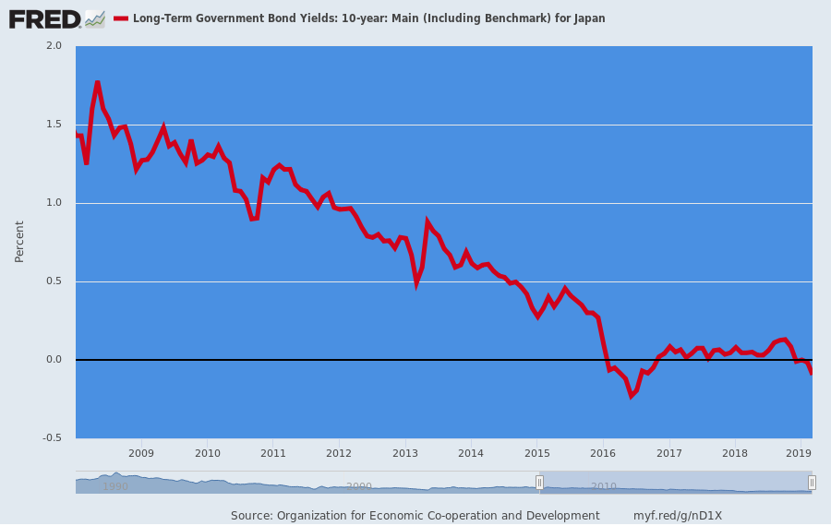
Moreover, when it comes to those humungous balance sheets----Kuroda truly does sound like an escapee from the loony bin. To wit, during the 19 years since 1999, the nominal GDP of Japan has increased by the scant sum of 5.6%---and were talking the total period, not per year.
By contrast, BOJ's balance sheet has expanded by just under 600% during that same 19 year period. So by any known historical norm of monetary policy, growing the central bank's balance sheet 107X faster than the GDP it services is, well, lunacy in action.
Indeed, if money printing were the elixir of growth, Japan's nominal GDP should have been rocketing, but it was actually crawling at a pace among the lowest on the planet during that span.
And it wasn't just an artifact of slightly negative inflation trend, either. Even Japan's real GDP during the 1999-2018 interval grew at only 0.95% per annum.
In other words, the BOJ has been pushing on a big, fat Ramen noodle for more than two decades, and it has not generated a revival of nominal GDP, inflation or real GDP.
Instead, it has merely fostered a hideous bloating of the BOJ's balance sheet, whereby the central bank now owns nearly half the government debt and 93% of the assets of the equity ETFs traded on Japan's markets---to say nothing of a boatload of corporate bonds, real estate loans and most anything else that has ever been hypothecated or securitized.
Moreover, the fact that Kuroda stands ready and willing to do more of the same is not merely a sign that they have gone off the deep-end on the Nipponese archipelago, which will soon be the world largest, bankrupt old age home.
BOJ-style Keynesian central banking and inflation-targeting was actually introduced to Japan in the late 1990s by an obscurantist US economist, who might be called the Admiral Perry of global money.
That is, it was Ben Bernanke himself who brought the black ships of Keynesian central banking folly to Japan, thereby transforming a post-1980s bubble malaise into a permanent case of economic entropy.
Just for want of doubt, recall that from 1953-1973 Japan's real GDP grew by 450% compared to 20% during the last two decades.
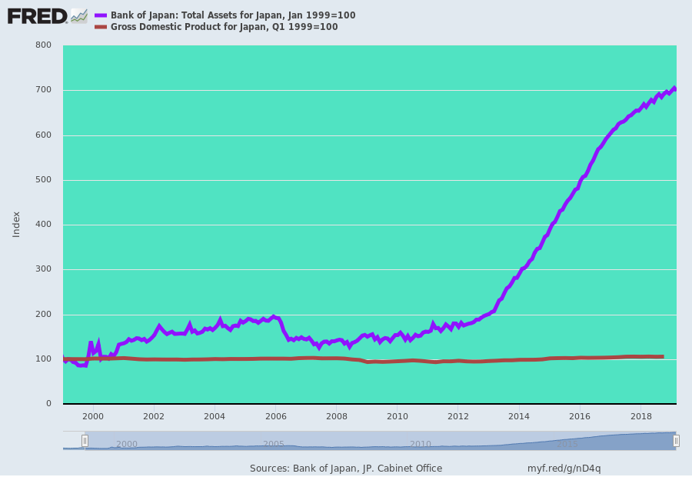
As is readily evident from the charts below, Bernanke's black ships have visited most of the central banks of the world. Today there is actually $10 trillion of sovereign debt bearing negative yields.
For instance, Germany's 10-year bund is a tad positive at +0.059%, but the front end of the bund curve is below the zero line, as are short-term Italian government bills.
That's right. Given Italy's disastrous 133% debt to GDP ratio, an economy that is smaller than it was a decade ago, an aging work force that is rapidly shrinking, and a left-right populist coalition nominally in charge of what passes for its government, you might have thought that lenders would not be happy to pay for the privilege of standing in harms' way.
Then again, that logical presumption fails to reckon with that ECB central bankers have joined the world-wide dash into monetary lunacy.
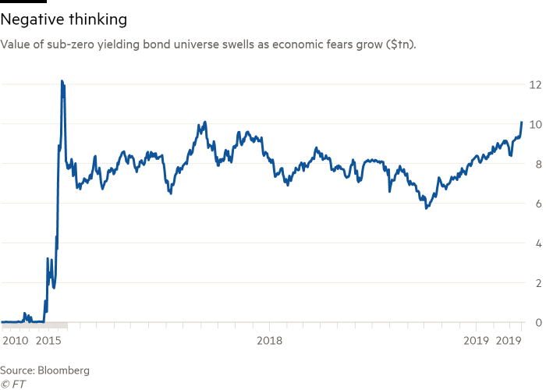
As we have previously contended, the essence of the Keynesian central banking evil is inflation targeting. Given that central bank financial repression inherently drives the cost of debt and other forms of capital to sub-economic levels, the inexorable effect on a worldwide basis has been vastly excessive over-investment and often grotesquely uneconomic malinvestment (as per the Red Ponzi)
In the long-term that [central bank financial repression ?] results in misallocated resources, deadweight loss of GDP and destruction of true wealth. But in the short-run it does generate powerful disinflationary effects owing to the tendency of firms to price at [only their] variable costs in the face of excess production and supply.
Yet the fools who run the central banks have become so addicted to Bernanke's 2.00% inflation targeting that they just keep injecting credit and liquidity into the financial markets in pursuit of this will-o-wisp. That obsession was made clear by Kuroda when he tried to explain why he still hasn't come close to the official 2.00% target since his super-QE campaign was launched in 2013.
What he actually said is that nominal wage growth in Japan has been moderate (owing to the risk of off-shoring of production to lower cost Asian venues) while productivity growth in the corporate sector has been reasonably strong. Therefore, he averred, companies "have not needed to raise prices."
Once upon a time, of course, the retort would have been, hurrah! Wealth is being generated by productivity gains and there is no inflationary distortion of the pricing system.
Not this morning, however. Madman Kuroda only sighed that he would keep trying hard to insure that inflation would finally get up on its hind-legs in Japan and run harder until it reached his sacrosanct target and, presumably, insured that all of these productivity gains would be eaten up by inflation.
And also, presumably, that he had completed the euthanization of the Japanese saver, which is already in a very advanced state due to the non-existent yields on banks accounts and bonds in the domestic economy.
During its growth heyday of 1955-1990, of course, the Japanese salarymen were the most voracious savers on planet earth. At its peak in the 1960s, the savings rate hit upwards of 20% and as late as 1994 was still north of 12%.
Then Bernanke came to Japan with his monetary black ships and it was soon all over except the shouting. Zero yields have produced a 2.0% +/- savings rate in Japan----and at the very time that Japan's old-age colony is rapidly liquidating the stock of savings and investments accumulated decades ago.
Needless to say, the old testament concept of a Jubilee (forgiveness of debts every 50 years) is about to have a modern day incarnation. That's because Japan has a central bank that is literally, happily and irrationally savaging the few remaining savers it has left, thereby insuring a feature of massive defaults when it mountains of debt cannot be rolled over.
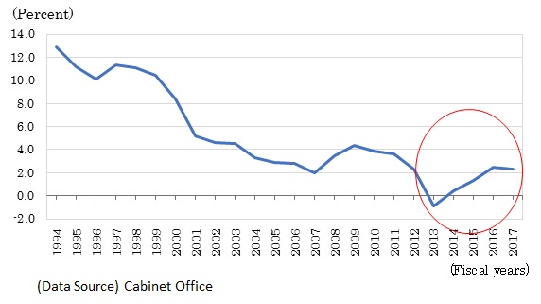
Needless to say, this inflation obsession would be bad enough if inflation of the general price level for goods and services were an immutable, objective thing subject to a divinely revealed measuring stick.
But actually, the popular price indices used in the US, Europe, Japan and elsewhere are simply bureaucrat confected approximations of a representative market basket of goods and services; and these guestimates have become subject to massive tinkering and subjective adjustments, such as for quality improvements or hedonics, in recent decades.
So to make them the lodestar for the pace at which the central bank runs its printing presses and artificially targets money market rates is an exercise in pure folly. And that's especially so because since the adoption of informal and then formal inflation targeting during the last 25 years, the apparatchiks at the government statistical mills have become ever more accommodating to the idea that rising prices are really not rising so much at all.
That is, not after they are "adjusted" for every manner of quality improvement that can be spotted in the marketplace, whether consumers ascribe much extra value or not. In recently addressing the matter, Porter Stansberry hit the nail on the head with a long-term price graph of the actual on-the-dealer lot transaction price for a Ford F-150 pick-up, the work horse of the construction, farming and blue collar economy.
In 1969, the cost was $2,500 and by 1997 it was about $18,000 before rising to $30,000 at present, and that's for the stripped down version. As Porter also notes, an F-truck you would actually want to buy today is priced at upwards of $45,000---or 18X its 1969 price.
Even the price tag for the stripped down version is up by 1,137%. Yet the average hourly wage for production and non-supervisory workers in the US is up from $3.25 per hour to $23.25 per hour or only 600% during the same 50-year period.
Moreover, during the years since 1997, the dealer lot price has risen from $18,000 to $30,000 or by 67%, while the BLS' hedonically adjusted series for new vehicle prices has not risen at all.
Our point here is not to lament the manner in which monetary central planning has shafted the America worker, although that is evident enough and it is the reason that American politics are being fractured into unprecedented dysfunction.
More narrowly, the F-150 cases makes abundantly clear that the published government inflation indices are an artifact of vast subjectivity, imprecision and manipulation; and, therefore, are exactly the last standard that should be used for the conduct of central banking and the preservation of honest money.

Price of a new Ford F-150 Since the 1960s
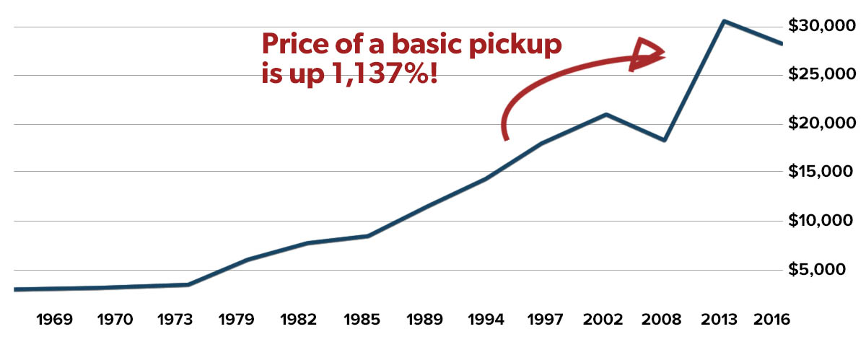
Source: NADA Guides via TheDrive.com
Yet the monetary politburo, led by Keynesian loony-birds like John Williams, is so manically wedded to inflation targeting that they are now seriously pushing for what they are pleased to call "price level targeting".
What that means, of course, is that any shortfall from the nonsensical 2.00% annual standard would be banked up in the price index and used to justify a higher than 2.00% annual targets in future years--- until the cumulative 2.00% price level was achieved.
So, no, madman Kuroda is not an outlier. He's representative of the population of most of the central banking fraternity.
And this gets us to the Donald's latest outbreak of economic crackpottery over the weekend. He tweeted that the market would be up to 10,000 points higher and growth north of 4% if only the Fed had not gotten in the way of his wondrous economic program, and had shifted back to more QE, not the short-lived and tip-toed into QT that it actually executed last year.
If the Fed had done its job properly, which it has not, the Stock Market would have been up 5000 to 10,000 additional points, and GDP would have been well over 4% instead of 3%...with almost no inflation. Quantitative tightening was a killer, should have done the exact opposite!
To be sure, the Trumpian boom is only a figment of the Donald's imagination and the talking point spinners in the White House and RNC. After $280 billion of tax cuts in 2018, in fact, the Q4/Q4 growth rate of real final sales growth (thus eliminating inventory fluctuations) posted at 2.588%.
Now, why did we resort to the spurious accuracy of the third decimal place after a completely unremarkable integer?
As it happened, the Q4/Q4 growth rate of real final sales in 2017---the year before the tax cut---was 2.586%!
So there's you're credit card financed tax cut at work, if you have to the magnifying class to detect it. Also, note that during the last upswing in global production during 2104 on Obama's watch, the Y/Y rates hit as high as 3.3% before falling back, as they are now again.
So here's the thing. When the central bankers have gone mad and destroyed every vestige of sound money and have turned the central bank into an economic management agency, which is inherently based on subjective politics, why would you expect the elected politicians to stand meekly on the sidelines?
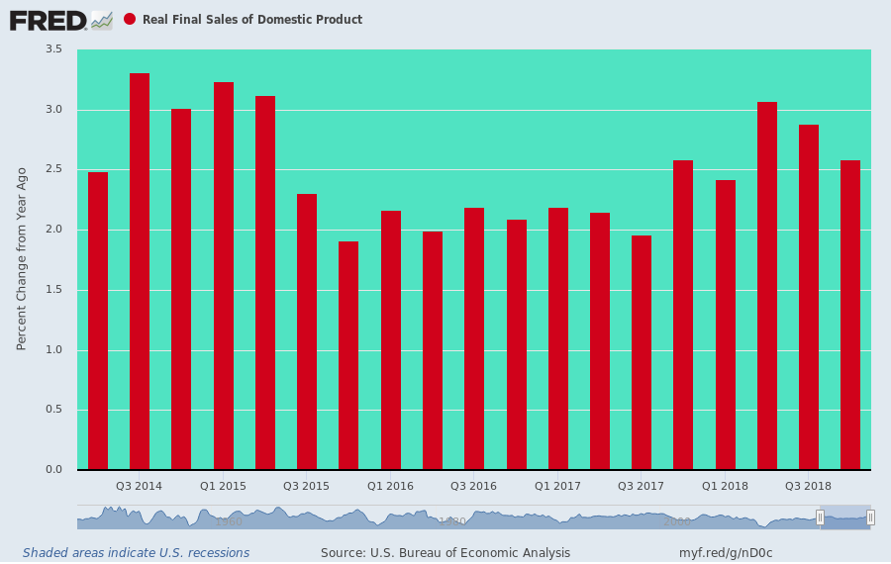
At the end of the day, it was Greenspan and Bernanke's black ships of Monetary Folly which brought the ill-wind of Donald Trump to the White House. Now their heirs and assigns will reap the whirlwind, and justly so.

